Emergency Preparedness
Planning Document Introduction
St. Elizabeth’s Hospital Auditorium
1100 Alabama Avenue, SE,
Washington, DC 20032
August 24th from 9:00 am to 1:00 pm

Participant
Manual

OTH
Solutions
Developed by:
United States Department
Health and Human Services
District of Columbia
Healthcare Association
With Support From:

This document was prepared for the:

District of Columbia Healthcare Association
1220 L Street, NW
Suite 100-242
Washington, DC 20005
Phone: 410 798 4925
Fax: 410 798 9260

Seminar was hoted at:
St. Elizabeth’s Hospital
1100 Alabama Avenue, SE
Washington, DC 20032

The seminar and participant manual were developed by:

OTHSolutions
Clifton, Virginia
(703) 915-2239

Project Coordinator Developer/Presenter
Bill Hyjek, Managing Partner Kent Schod, Healthcare Emergency Manager
Bill.Hyjek@othsolutions.net kent.schod@othsolutions.net

Table of Contents

SECTION 1: Introductions and Administrative Activities 1
INTRODUCTION 1
ADMINISTATIVE NEEDS 1
Course Introduction 1
ENABLING LEARING OBJECTIVES 2
Group Introduction and Course Needs 2
SECTION 2: Introduction to Hazard Vulnerability Assessments 3
Hazard Vulnerability Assessments (HVA) 3
HVA Regulatory Requirements 3
Components of a HVA 5
Four Components of Risk Assessment 5
Advanced Components of a HVA 5
HVA Models 6
HVA Development Exercise 7
Developing Your HVA 7
HVA Tool – Facility Data Page 8
HVA Tool – Hazard Analysis Page 8
Review of the HVA Section 9
SECTION NOTES 9
SECTION 3: Emergency Operations Plans 11
Emergency Operations Plan 11
Origin of EOPs 11
EOP Regulatory Requirements 12
Additional Planning Considerations 13
EOP and the Preparedness Cycle 13
Basic Components of an EOP 14
Organizational Structure 14
EOP Base Plan 15
EOP Annexes 15
Incident Annexes 16
Appendices 16
Development for Healthcare Facilities 16
Publishing the EOP 17
Next Steps 17
Additional Keys for Developing Plans (1 of 2) 17
SECTION NOTES 18
SECTION 4: Communications Plans 19
Communications Planning (CommPlan) 19
Crisis & Risk Communications Defined 19
Regulatory Requirements for CommPlans 20
Planning Principles for CommPlans 20
Plan Components for CommPlans 21
CommPlan Development 21
Publishing the CommPlan 21
Next Steps 22
Review of the CommPlan Section 22
Discussion and Break 22
SECTION 5: Drills and Exercises Development 23
Drill and Exercise Planning 23
Overarching Purpose of Drills and Exercises 23
Types and Purposes of Exercises 24
Regulatory Requirements for Drills and Exercises 25
Development Considerations for Drills and Exercises 26
Facilitation Considerations for Drills and Exercises 28
Evaluation Considerations 28
Documenting Your Efforts – EEGs 28
Documenting Your Efforts-AAR/LL 29
Lessons Learned: 30
Improvement Plan: 30
Drills and Exercises Section Review 30
SECTION NOTES 30
SECTION 6: Wrap-Up and Departure 31
Course Review 31
Comments, Questions, & Concerns 31
Documents Deadline Reminder 31
Additional Assistance from OTH Solutions 31
APPENDIX A – Acronyms and Abbreviations 1
APPENDIX B – Emergency Operations Plan Overview 1
APPENDIX C – Communications Plan Overview 1

This page intentionally left blank.

SECTION 1: Introductions and Administrative Activities

Slide 1 | INTRODUCTION  This presentation has been sponsored by the District of Columbia Health Care Association (DCHCA) an effort to support the regulatory requirements of the Centers for Medicare and Medicare for skilled nursing centers within the United States. The presentation has been created to assist the healthcare facilities within the district prepare for the document requirements which are due November 17th, 2017.  Contained herein are basic instructional components to assist the facilities complete the following documents:  - Hazard Vulnerability Assessments (HVA)  - Emergency Operations Plans (EOP)  - Communications Plans. (CommPlan)
Slide 2 | ADMINISTATIVE NEEDS  Before beginning the course, a few points of reference should be introduced:  - Course is divided into four sections with each running about 45 minutes long.  - 15 minute breaks will separate each teaching section.  - Bathrooms  - Refreshments  - In the event of an emergency:  - Emergency Exits  - Class assembly areas  A request from the presenters and fellow participants - please place all cell phones and electronic devices on mute or vibrate.  Opening Comments from the course sponsors.
Slide 3 | Course Introduction  This course is designed to provide assistance to those individuals assigned to planning for non-routine emergency situations within their facilities. The course has been designed specifically for the skilled nursing care facilities who reside within the District of Columbia.

Slide 4 | ENABLING LEARING OBJECTIVES  The Enabling Learning Objectives (ELOs) have been written to support the needs of the staff who are tasked with the responsibility to research, prepare, and submit a Hazard Vulnerability Assessment, Emergency Operations Plans, and Communications Plan for their facility. The last  - ELO 1: Given a Hazard Vulnerability Assessment (HVA) tool, the participants will be able to retain a general concept of what an HVA is, its parts, and how to complete the HVA using one of the many tools available.  - ELO 2: Given an outline of the contents of an Emergency Operations Plan, the participants will be able to apply their knowledge of format and content requirements to draft a compliant EOP that meets the needs of their facility. This will include the policies and procedures which are needed to execute their emergency operations and communications plans.  - ELO 3: Given an outline of the contents of a Communications Plan (CommPlan), the participants will be able to apply their knowledge of format and content requirements to draft a compliant CommPlan that meets the needs of their facility.  - ELO 4: Given an introduction to healthcare facility drills and exercises, the participants will be able to draft a basic drill or exercise guideline that will outline the areas within their emergency operations or communications plans which require testing and evaluation.
Slide 5 | Group Introduction and Course Needs  To get to know each other better for the next four hours, the group will participate in this exercise.  - Instructor Introduction  - Group Introductions – Tell the group your Name and facility you are with.  - Participant Requests – During your self-introduction, let the instruction know something about what you would like to get out of this class.

SECTION 2: Introduction to Hazard Vulnerability Assessments
Slide 6 | Hazard Vulnerability Assessments (HVA)  What is a Hazard Vulnerability Assessment?  Hazard identification and risk assessment provides the factual basis for activities proposed in the strategy portion of a hazard mitigation plan. An effective risk assessment informs proposed actions by focusing attention and resources on the greatest risks.  A disaster occurs when an extreme event exceeds a community’s ability to cope with that event. Understanding the process by which natural disasters produce community impacts is important for four reasons.  - Information from this process is needed to identify the preimpact conditions that make communities vulnerable to disaster impacts.  - Information about the disaster impact process can be used to identify specific segments of each community that will be affected disproportionately (e.g., low income households, ethnic minorities, or specific types of businesses).  - Information about the disaster impact process can be used to identify the event-specific conditions that determine the level of disaster impact.  - An understanding of disaster impact process allows planners to identify suitable emergency management interventions.  An HVA can help to provide this information to planners and provides a point of origin for response and recovery planning.  SOURCE: Hazard Planning Guide: Chapter 6- Hazard, Vulnerability, And Risk Analysis, Page 153. FEMA 1998
Slide 7 | HVA Regulatory Requirements  Only within the last 15 years has emergency management and disaster preparedness been in the foreground of healthcare planning. Because of events like Hurricane Katrina and Rita and the tornados in Joplin, Missouri; regulatory agencies have been working to ensure that healthcare facilities are safe for staff, patients and family and visitors.  Requirements for having and maintaining an HVA include:  Continued on the next page.

Slide 7 continued…  Slide 8 | - The emergency plan includes strategies for addressing emergency events identified by the risk assessment.  - Joint Commission: EM.01.01.01  - NFPA 1600: 4.4.2, 5.1.3, 5.1.4, 5.1.5, 5.2.1, 6.6.2  - NFPA 99: 12.5.3.2 & 12.5.3.  - CMS Regulations:  - Clinics, Rehab & Therapy Centers - 485.727a2  - Community Mental Health Centers - 485.920a2  - Immediate Care Facilities - 483.475a2  - The emergency plan must be based on, and include, a documented facility based and community based risk assessment utilizing an all hazards approach including missing clients  - Joint Commission: EM.01.01.01 and EM.03.01.01  - NFPA: 4.4.2, 5.1.3, 5.1.4 and 5.2.1  - CMS Regulations:  - Clinics, Rehab & Therapy Centers - 485.727a1  - Community Mental Health Centers - 485.920a1  - Immediate Care Facilities - 483.475a1  - Long Term Care Facility - 483.73a1  - Program All Inclusive C Eld - 460.84a1  - Psychiatric Residential Treatment Facility - 441.184a1  - Religious Non-Medical Healthcare Institution - 403.748a1  - The plan must be based on a community risk assessment using an all‐hazards approach with each separately certified facility within the health system having a documented individual facility based risk assessment.  - CMS Regulations:  - Clinics, Rehab & Therapy Centers - 485.727e  - Community Mental Health Centers - 485.920e  - Long Term Care Facility - 483.73f4i  - Program All Inclusive C Eld - 460.84e4i‐ii  - Psychiatric Residential Treatment Facility - 441.184e4i‐ii  - Address patient population, including, but not limited to, persons at‐risk, the type of services in the healthcare facility, the ability to provide services during an emergency; and continuity of operations, including delegations of authority and succession plans.  - NFPA 1600: 6.8.2  - NFPA 99: 12.3.3.4  - CMS Regulations:  - Religious Non-Medical Healthcare Institution - 403.748a3
Slide 9 | Components of a HVA  Four Components of Risk Assessment  The four basic components of Risk Assessment are below and make up the foundation of all risk evaluating.  - Hazard Identification – Creating a unified definition of the hazard or threat. This includes subdivisions of types of hazards or threats.  - Hazard Event Frequency – This is the identification of frequency of the threat or hazard occurring and is usually based on how often an even happens between so many years.  - Asset Inventory – This includes an evaluation of the assets and resources the facility has in preparation for and readiness to respond, and or recover, from the threat or hazard.  - Resource Loss Projection - This usually includes human, economic losses based on the exposure and vulnerability of people, buildings, and infrastructure.  Advanced Components of a HVA  There are other aspects of HVA development that are not included in the basic models covered within this course. These may include:  - Secondary Threat Assessments - In some cases, one hazard or threat may also include other identified hazards or threats as part of that situation. Examples of these threats include:  - Internal Fire Threat may also include internal flooding, utility failure, mass casualty, mass fatality, etc.  - Hurricanes may include fires, utility losses, mass casualties, mass fatalities, supply losses, loss of personnel, and other occurrences which are also listed as hazards or threats.  By identifying and recognizing these secondary threats, planners may have a better insight to the next level of events to plan for, additional considerations, or referencing other supporting plans (aka annexes and covered in the next section).  - Weighted Assessment Ratings – Providing modified ratings to the HVA, the planner recognizes and assigns a higher risk value to some threats or hazards because of conditions that may not be hazards or threats themselves but can enhance conditions.  Examples may include:  - Effects of Uninsured/Underinsured populations during a pandemic or epidemic.  - Effects of Special Population on the resource needs of a facility’s response and recovery planning

Slide 10 | HVA Models  There are a number of HVA tools available to use. Some have been especially prepared for healthcare while others were written to support other industries, communities, or events. Below are three examples.  Example 1: Generic HVA Evaluation Tool  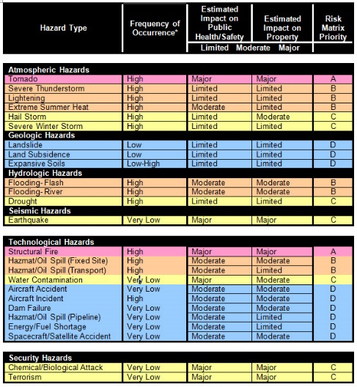  this generic HVA tool used the basic concept of frequency plus the sum average of the resource loss to identify the overall threat risk.  There is no adjustment for preparedness efforts made and the scaling system is very subjective.  Example 2: Community-based Risk Screening=Adaption and Livelihoods (CRiSTAL) Tool  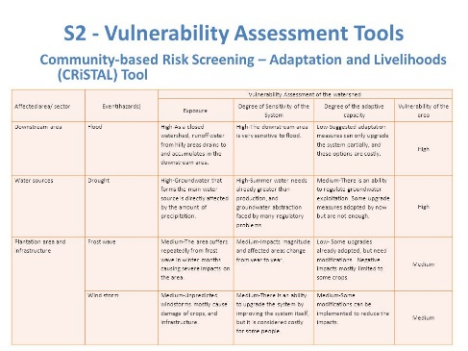  In this model was developed for environmental assessments for cities, recreational areas, and other geographic areas. The Event hazards are grouped and evaluated by geographic locations.  The Resource Loss Projections are based on the Exposure (effect) to the locations being evaluated, the Sensitivity or disruption to the environment, and Degree of Adaptive Capacity or mitigative efforts that could reduce the losses to the area. The risk rating is for the threat/hazard being evaluated and the overall vulnerability to the area being assessed.  The assessment is limited in its ability to identify additional aspects of the threat, such as how often does the threat occur, are resources available to mitigate or reduce the threat, or are the threats a high-dollar loss that may indicate more immediate measures need to be evaluated. There is also no consideration for injuries or fatalities to the community populations included in these areas.

Slide 10 continued… | HVA Models continued…  Example 3: Kaiser Permanente (KP) Model  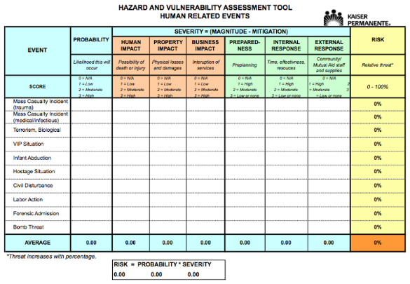  The KP model was developed for the healthcare industry over 15 years ago and has gone through a number of revisions. It may be considered the most popular HVA tool available.  The tool uses the traditional Frequency + Loss Projection – Preparedness equals the rating. Each of the categories are rated on a subjective High, Medium, and Low rating. This does not provide for standardized evaluations or measurements.  For this course, the instructor will concentrate on the HVA tool that was developed for the DCHCA and its members.
Slide 11 | HVA Development Exercise  ?  For this exercise, please estimate the What is the average annual snowfall, in inches, over the past 10 years in the District of Columbia?  Place your answer in the box provided and don’t share your answer with anyone.
Slide 12 | Developing Your HVA  Steps to developing your facility specific HVA:  - Identify threats – Build a list of the possible threats or hazards to your facility.  - Evaluate threats against:  - Probabilities – History and Future Occurrences  - Impacts – Human, Property, Business, Social, etc.  - Preparedness – Mitigation, Planning, Exercises, etc.  - Calculate the threats based on the evaluations.  - Mitigate threats, where possible.  - Begin planning for threat occurrence based on risk.

Slide 13 | HVA Tool – Facility Data Page  This tool was developed to support the needs of the DC facilities.  - The first page is a cover page with the second being the instructions page.  - The third worksheet is this facility data page. It contains two parts:  - The first, the user will enter data about their facility.  - The second, the user can enter the various threat or hazard titles and provide a definition for each. This data will be used on the next page.
Slide 14 | HVA Tool – Hazard Analysis Page  On this page, the user has a series of columns which require the selection of data so the system can rank the hazards.  Using the pull-down menus, the user selects the pre-defined analysis for the probability, loss projection, and preparedness levels for the facility.  The columns include:  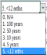  - Threats/Hazards Listing (Gray)  - Historical Probability Assessment (1st Blue)  - Future Probability Assessment (2nd Blue)  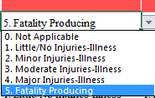  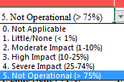  - Human Site Impact Assessment (1st Red)  - Property Site Impact Assessment (2nd Red)  - Business Site Impact Assessment (3rd Red)  - Planning Efforts Assessment (1st Green)  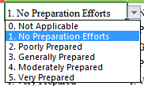  - Internal (Physical) Preparedness Assessment (2nd Green)  - External (Physical) Preparedness Assessment (3rd Green)  - Threat/Hazard Rating (Yellow)  By selecting the various assessments for each column, the system generates the threat/hazard rating.

Slide 15 | Review of the HVA Section  Information covered in the HVA section included:  - Definition of an HVA.  - Reviewed the Regulatory Requirements for a HVA.  - Reviewed the Components of an HVA.  - Identified various Models of HVAs.  - Reviewed the Development Aspects of a HVA.
Slide 16 | Discussion and Break Period  - Questions, comments, and discussion opportunity  - 15-minute break  - Refreshments

SECTION NOTES

This page intentionally left blank.

SECTION 3: Emergency Operations Plans

Slide 17 | Review of the Course Thus Far  Progress thus far:  - Opening remarks, course introduction, and administrative needs.  - Learning Objectives  - Hazard Vulnerability Assessments  - Emergency Operations Planning  - Communications Planning  - Drills and Exercise Planning  - Conclusion
Slide 18 | Emergency Operations Plan  What is an EOP?  Emergency Operations Plans (EOP) describes how a facility will respond to and recover from all hazards. When planning for healthcare facilities, other requirements from organizations such as:  - The Joint Commissions (TJC)  - National Fire Protection Agency (NFPA)  - Federal and State Occupational Safety and Health Administrations (OSHA)  - Centers for Medicaid and Medicare Services (CMS).  The elected and appointed leaders within each facility are responsible for ensuring that necessary and appropriate actions are taken to protect people and property from any threat or hazard. When threatened by any hazard; staff, residents, families of residents, and visitors to the facility expect facility leaders to take immediate action to help them resolve the problem. Residents and staff expect the facility to marshal its resources, channel the efforts—including external partners, local governments, emergency response agencies and voluntary organizations—to solicit the necessary assistance to resolve and overcome the event.  Origin of EOPs  The information and plan template presented in this presentation follows the format established in the Federal Emergency Management Agency’s (FEMA) Comprehensive Preparedness Guide (CPG) 101: Developing and Maintaining State, Territorial, Tribal, and Local Government Emergency Plans, November 2010.

Slide 19 | EOP Regulatory Requirements  By creating and maintaining an EOP, there are a number of regulatory requirements that are fulfilled. These include:  - Joint Commission – 28 requirements  - National Fire Protection Agency – 60 requirements  - Federal Occupational Safety and Health Administration – 22 requirements  - Centers for Medicare and Medicaid Services:  - Clinics, Rehab & Therapy Centers (485.7xx) – 32 requirements  - Community Mental Health Centers (485.9xx) – 35 requirements  - Immediate Care Facilities - Intellectual ID (483.4xx) – 30 requirements  - Long Term Care Facility (483.7xx) – 41 requirements  - Program All Inclusive C Eld (460.8xx) – 39 requirements  - Psychiatric Residential Treatment Facility (441.1xx) – 37 requirements  - Religious Non-Medical Healthcare Institution (403.7xx) – 30 requirements  - American Association for Accreditation of Ambulatory Surgery Facilities – 4 requirements
Slide 20 | Planning Considerations for EOPs  Components an EOP should consider incorporating within it:  - Prevention consists of actions that reduce risk from human-caused incidents.  - Protection reduces or eliminates a threat to people, property, and the environment. Primarily focused on adversarial incidents, the protection of critical infrastructure and key resources (CIKR) is vital to local jurisdictions, national security, public health and safety, and economic vitality.  - Response embodies the actions taken in the immediate aftermath of an incident to save and sustain lives, meet basic human needs, and reduce the loss of property and the effect on critical infrastructure and the environment. Following an incident, response operations.  - Recovery encompasses both short-term and long-term efforts for the rebuilding and revitalization of affected communities.  - Mitigation, with its focus on the impact of a hazard, encompasses the structural and non-structural approaches taken to eliminate or limit a hazard’s presence; peoples’ exposure; or interactions with people, property, and the environment.

Slide 20 continued… | Additional Planning Considerations  The EOP is an “all hazards” guidance document that specifies actions to be taken in response to an emergency or disaster. It describes how the healthcare organization’s response structure is organized and how it will respond during an emergency.  The EOP is helpful in developing and conducting education, training, and exercises, as well as in evaluating facility’s performance in exercises or actual emergencies.  The EOP must be usable under emergency conditions to guide response actions, demobilization, recovery, and return to readiness. The components of an EOP designed for use during response are the specific “tools,” including call-down lists, operational checklists, mobilization and demobilization procedure checklists, reporting templates, and other standard operating procedures (SOPs).
Slide 21 | EOP and the Preparedness Cycle  Developing an EOP is a major, key component of the planning and typically the entry point into the preparedness cycle. Planning is usually the entry point for facility staff getting involved in disaster preparedness. The cycle includes:  - Planning activities which include HVAs, mitigation plans, EOPS, Annexes, and SOPs/SOGs.  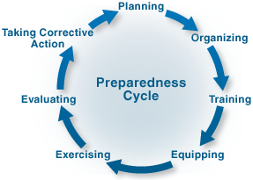  - Organization of the facility response and recovery efforts.  - Training staff based on the plans prepared.  - Equipping response staff with the resources they need.  - Exercising the plans and equipment (Section 4)  - Evaluating the exercises, plans, and other components of the preparedness cycle to ensure they achieve their goals.  - Corrective Action activities ensure that improvements are made.  The cycle does not end with Corrective Actions but returns to the planning phase where enhanced plans are developed based on lessons learned from the steps in the cycle.

Slide 22 | Basic Components of an EOP  The management structure and methodology that will be used in an emergency, including the organization and operation of the internal HCO Incident Command Post (ICP). This should be easily identifiable to external coordinating agencies.  - General organizational descriptions of Operations, Planning, Logistics, and Administration/Finance Sections, which personnel perform them, and the processes/procedures to be used.  - Essential activities to be performed during each stage of emergency response. These activities should be coordinated with other HCOs and with jurisdictional incident management to maximize MSCC across the system.  - Methods for adequately processing and disseminating information during an emergency, including names and contact information for external liaisons and contacts at other HCOs and the jurisdictional level.  - Processes to promote continuity of HCO operations, including patient care, business continuity, and pre-identified sources for external support (e.g., mutual aid partner facilities).  - Guidance on how to develop and release public messages during emergencies, including coordination with the jurisdiction public information function.  - Guidance for very unusual hazards or for special circumstances, such as hospital evacuation or “shelter in place.” Typically addressed in annexes to the EOP, this guidance should use the same processes established for other emergencies.

Organizational Structure

The material developed for the EOP should be formatted for ease of use during response and recovery yet must remain comprehensive. This EOP format is consistent with the common format of other disciplines and is consistent with the NRP format:
Introduction (may be considered part of the Base Plan)
- Title page
- List of changes (with dates) to the EOP
- Table of contents
- Executive summary: Provides an awareness level of proficiency with the EOP.

Slide 22 continued… | Organizational Structure continued…  EOP Base Plan  Provides an understanding of how the organization responds and how it interfaces with the outside environment during response. Essential sections include:  - Introductory Information  - Purpose, Scope, Situation Overview, and Assumptions (Foundation and background)  - Concept of Operations (Flow of Ops)  - Organization and Assignment of Duties (OrgChart)  - Direction, Control and Coordination (Who does what, when)  - Information Collection, Analysis, and Dissemination (Intelligence gathering)  - Communications  - Administration, Finance, and Logistics  - Plan Development and Maintenance  - Authorities and References  SOURCE: Comprehensive Planning Guide (CPG) 101, FEMA 2010
Slide 23 | EOP Annexes  Functional Annexes  Specific more detailed description of the response guidance for each functional area, including;  - Each functional annex provides the general response objective for the functional area, the response structure, activation and mobilization procedures specific to that function, and its concept of operations  - Position descriptions and qualifications, operational checklists (job action sheets) for positions  - Forms (including ICS forms) and other jobs aids to accomplish the tasks.  Support Annexes  Specific processes and procedures that apply to all or most of the response functions and support response and recovery, including:  - Common administrative requirements  - Continuity of operations process and procedures  - Occupant emergency procedures  - Worker safety and health procedures  - Media policy and procedures  - Resource ordering procedures  - Response and recovery financial management procedures  - Emergency credentialing and privileging of volunteers and mutual aid personnel

Slide 23 continued… | EOP Annexes continued…  Incident Annexes  Contingency considerations for specific hazards, sites, and situation (roles, responsibilities, procedures), to include pre-plans for common hazards, such as:  - Weather emergencies  - Hazardous materials  - Infectious disease outbreak  - Explosive threat  - Security situations  - Infant abduction  - Care for the High Level Protectee  - Civil disturbance  - Others as identified through HVA.  Appendices  Additional materials that are relevant to guidance for emergency response and recovery, including:  - Glossary  - Acronyms  - Authorities (if not incorporated into the Introduction)  - Compendium of pertinent local and regional response plans and procedures  - Resource lists and content information  SOURCE: Medical Surge Capacity and Capability: A Management System for Integrating Medical and Health Resources During Large-Scale Emergencies, Second Edition, September 2007: DHHS
Slide 24 | Development for Healthcare Facilities  An outline for a healthcare EOP has been provided in the participant manual and includes:  - Traditional EOP structure  - Annexes to support focused response and recovery activities.  Please refer to Appendix A of this manual to see the expanded EOP sample.

Slide 25 | Publishing the EOP  Once the EOP has been written and proofed, the facility should:  - Have it vetted by the facility’s emergency management committee! Don’t have one? Then have it reviewed by major department heads within the facility.  - Have the document authorized by facility leadership.  - Consider sharing the plan with:  - Local healthcare agencies, such as: Department of Health, DCHCA, neighboring facilities who may need to support your facility in an emergency.  - Local emergency service agencies, such as: local fire, emergency medical, police, and emergency management agencies.
Slide 26 | Next Steps  EOPs are dynamic, not static. They require:  - Annual review of the plan. Some annexes need to be evaluated annually, while others can be evaluated every three years.  - Testing of an EOP. EOPs need to be tested, under controlled environments, to ensure that the plans will meet the needs of the situations they were developed for; these come in the form of drills and exercises.  - Evaluation and updating may need to occur because:  - The environment they were prepared for has changed.  - Testing revealed shortcomings.  - Mitigative efforts have changed the hazards or threat conditions
Slide 27 | Additional Keys for Developing Plans (1 of 2)  When developing an EOP, the writer should consider planning:  - Considers all hazards and threats.  - Be community-based, representing the whole population and its needs.  - Include participation from all stakeholders in the community and senior officials throughout the process to ensure both understanding and approval (from leadership).  - Using a logical and analytical problem-solving process to help address the complexity and uncertainty inherent in potential hazards and threats.  - Should be flexible enough to address both traditional and catastrophic incidents.

Slide 28 | Additional Keys for Developing Plans continued…  - Should anticipate the environment for action.  - Does not need to start from scratch.  - Identifies tasks, allocates task resources, and establishes accountability.  - Should consider influences, such as time, uncertainty, risk, and experience.  - Clearly identify the mission and supporting goals (with desired results).  - Effective plans tell those with operational responsibilities what to do and why to do it, and they instruct those outside the facility in how to provide support and what to expect.  - As a fundamental process to manage risk.
Slide 29 | Review of EOPs  Topics covered in this section include:  - Development and History of EOPs  - Regulatory Requirements of EOPs for Healthcare Facilities  - Considerations for Planning EOPs  - Preparedness Cycle  - Components of EOPs: Basic Plan and Annexes  - Sample Format for Healthcare Facilities  - Publishing the EOP  - Next Steps  - Additional Considerations.

SECTION NOTES

SECTION 4: Communications Plans

Slide 30 | Communications Planning (CommPlan)  What is a Communications Plan?  - There are various types of Communications Plans within disaster preparedness and emergency planning. Some of these include:  - Crisis and Risk Communications  - Family Communications Planning  - Information and Public Alert Warning Systems (IPAWS)  - Corporate Communications Planning  - Communications Plans for Healthcare Emergency Management are considered “Crisis and Risk Communications” plans. This is based on:  - Needs of the EOP to communicate with leadership, staff, patients, and families.  - Definitions of the various regulatory requirements for healthcare facilities.
Slide 31 | Crisis & Risk Communications Defined  Definition of “Crisis and Risk Communications” plans:  - Describes the communication activities of an organization or agency facing a crisis. They need to communicate about that crisis to their organization, various partners, and the public.  - Are associated more with emergency management and the need to inform and alert the public about an event. In this case, crisis communication might refer to the facility’s efforts to inform the public.  Conditions dictating the establishment of these plans:  - Occurs unexpectedly  - May not be in the organization’s control  - Requires an immediate response  - May cause harm to the organization’s reputation, image, or viability  Source: Crisis and Emergency Risk Communication, 2014 Edition, US DHHS, CDC

Slide 32 | Regulatory Requirements for CommPlans  By creating and maintaining a facility CommPlan, there are many regulatory requirements that are fulfilled. These include:  - Joint Commission – 4 requirements  - National Fire Protection Agency – 11 requirements  - Federal Occupational Safety and Health Administration – 1 requirement  - Centers for Medicare and Medicaid Services:  - Clinics, Rehab & Therapy Centers (485.7xx) – 4 requirements  - Community Mental Health Centers (485.9xx) – 6 requirements  - Immediate Care Facilities - Intellectual ID (483.4xx) – 4 requirements  - Long Term Care Facility (483.7xx) – 6 requirements  - Program All Inclusive C Eld (460.8xx) – 5 requirements  - Psychiatric Residential Treatment Facility (441.1xx) – 5 requirements  - Religious Non-Medical Healthcare Institution (403.7xx) – 5 requirements  - American Association for Accreditation of Ambulatory Surgery Facilities – 1 requirement
Slide 33 | Planning Principles for CommPlans  Nine Principles to Crisis Communications Planning:  - Focus on the needs of your customers.  - Make a commitment to effective communications.  - Make communications an integral part of all Planning and Operations.  - Be transparent in your communications.  - Ensure that your information is accurate.  - Release information in a timely manner.  - Make yourself, your staff, and others, where appropriate, available and accessible.  - Create an emotional connection with your audience.  - Build a partnership with the media and the “first informer” community.  Source: FEMA Crisis and Risk Communications Course: Session 2: Introduction to Communications in the Emergency Management Context

Slide 34 | Plan Components for CommPlans  Basic Components of a CommPlan include:  - Administrative Section, including: Purpose, Scope, Situation Overview, and Assumptions (Foundation and background)  - Concept of Operations (Flow of Ops)  - Public Warning and Alert Systems  - Public Information Staff  - Patient Records Management  - At-Risk Populations Planning  - Communications Resources (Logistics)  - Plan Development and Maintenance  - Authorities and References  Refer to the sample CommPlan provided in Appendix C of this Manual.
Slide 35 | CommPlan Development  When developing the CommPlan, consider the following activities:  - Identify the main goals for the CommPlan. This may include: Notifying or recalling staff, informing the public of an incident, and other incident related activities.  - Collect the following resources:  - Facility communications equipment information.  - Facility protocols, procedures, and other facility-based guidance for communicating before, during, and after an incident.  - Resources and support available from external partners.  - Seek planning support from leadership, local emergency management officials, DC Department of Health, and others who can assist developing the plan.  - Identify who may be considered “At-Risk” populations and what resources may be required to include these people within the plan.
Slide 36 | Publishing the CommPlan  Once the CommPlan has been written and proofed, the facility should:  - Have it vetted by the facility’s emergency management committee. Don’t have one? Then have it reviewed by major department heads within the facility.  - Have the document authorized by facility leadership.

Slide 36 continued… | Publishing the CommPlan continued…  - Consider sharing the plan with:  - Local healthcare agencies, such as: Department of Health, DCHCA, neighboring facilities who may need to support your facility in an emergency.  - Local emergency service agencies, such as: local fire, emergency medical, police, and emergency management agencies.
Slide 37 | Next Steps  EOP Annexes, including the CommPlan are dynamic, not static. They require:  - Annual review of the plan. Some annexes need to be evaluated annually, while others can be evaluated every three years.  - Test the CommPlan regularly. All EOP Annexes need to be tested, under controlled environments, to ensure that the plans will meet the needs of the situations they were developed for. These come in the form of drills and exercises.  - Evaluation and updating may need to occur because:  - The environment they were prepared for has changed.  - Testing revealed shortcomings.  - Mitigative efforts have changed the hazards or threat conditions.
Slide 38 | Review of the CommPlan Section  In this section, we have:  - Definitions and examples of CommPlans  - Regulatory requirements for CommPlans in Healthcare facilities.  - CommPlan Principals, Components, and Development needs.  - Publishing the CommPlan  - Next Steps
Slide 39 | Discussion and Break  Additional Questions or Comments regarding:  - Emergency Operations Planning  - Communications Planning  15 Minute Break

SECTION 5: Drills and Exercises Development

Slide 40 | Review of the Course Thus Far  Progress thus far:  - Opening remarks, course introduction, and administrative needs.  - Learning Objectives  - Hazard Vulnerability Assessments  - Emergency Operations Planning  - Communications Planning  - Drills and Exercise Planning  - Conclusion
Slide 41 | Drill and Exercise Planning  Plans, procedures, and guidelines need to be practiced and tested to ensure that they will function when needed. Drills and Exercises are one way of accomplishing this.  Based on regulatory requirements, drills and exercises should follow FEMA’s Homeland Security Exercise and Evaluation Program’s (HSEEP) guidance for developing, facilitating, evaluating, and reporting on drills and exercises within your facility.
Slide 42 | Overarching Purpose of Drills and Exercises  Overarching purpose of drills and exercises:  - They play a vital role in preparedness by enabling whole community stakeholders to test and validate plans and capabilities, and identify both capability gaps and areas for improvement.  - A well-designed exercise provides a low-risk environment to test capabilities, familiarize personnel with roles and responsibilities, and foster meaningful interaction and communication across organizations.  - Exercises bring together and strengthen the whole community in its efforts to prevent, protect against, mitigate, respond to, and recover from all hazards.  - Overall, exercises are cost-effective and useful tools that help practice and refine our collective capacity to achieve the core capabilities in preparedness goals of the facility, the community, and the nation.

Slide 43 | Types and Purposes of Exercises  HSEEP Definition of Drills and Exercises:  - Seminars – Discussion-based, awareness-level exercise with the goal to orient participants to, or provide an overview of, authorities, strategies, plans, policies, procedures, protocols, resources, concepts, and ideas.  - Workshops – Although similar to seminars, workshops differ in two important aspects: Participant interaction is increased, and the focus is placed on achieving or building a product. Products produced from a workshop can include new standard operating procedures (SOPs), emergency operations plans, continuity of operations plans, or mutual aid agreements.  - Tabletop Exercises (TTX) – A TTX usually focused on a hypothetical, simulated emergency; aimed at facilitating conceptual understanding, identifying strengths and areas for improvement, and/or achieving changes in perceptions; and have a primary goal to enhance general awareness, validate plans and procedures, rehearse concepts, and/or assess the types of systems needed to guide the prevention of, protection from, mitigation of, response to, and recovery. TTXs can range from basic to complex.
Slide 44  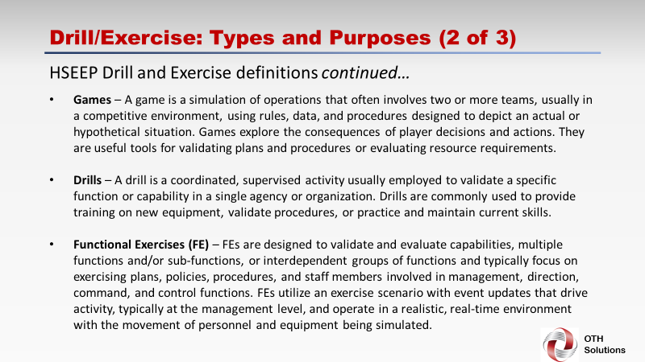 | - Games – A game is a simulation of operations that often involves two or more teams, usually in a competitive environment, using rules, data, and procedures designed to depict an actual or hypothetical situation. Games explore the consequences of player decisions and actions. They are useful tools for validating plans and procedures or evaluating resource requirements.  - Drills – A drill is a coordinated, supervised activity usually employed to validate a specific function or capability in a single agency or organization. Drills are commonly used to provide training on new equipment, validate procedures, or practice and maintain current skills.  - Functional Exercises (FE) – FEs are designed to validate and evaluate capabilities, multiple functions and/or sub-functions, or interdependent groups of functions and typically focus on exercising plans, policies, procedures, and staff members involved in management, direction, command, and control functions. FEs utilize an exercise scenario with event updates that drive activity, typically at the management level, and operate in a realistic, real-time environment with the movement of personnel and equipment being simulated.  Continued on the next page…
Slide 45  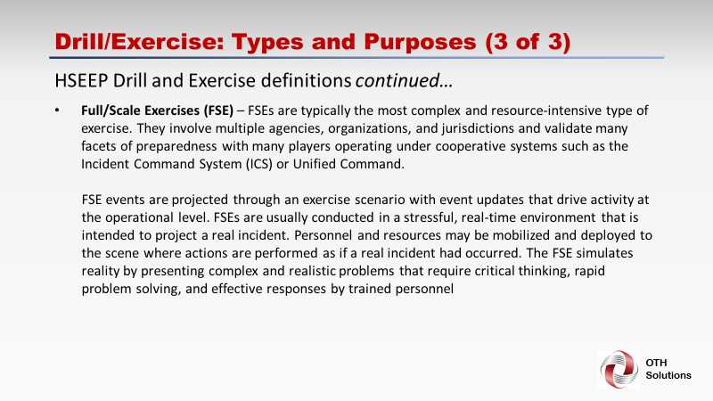 | Types and Purposes of Exercises continued…  - Full/Scale Exercises (FSE) – FSEs are typically the most complex and resource-intensive type of exercise. They involve multiple agencies, organizations, and jurisdictions and validate many facets of preparedness with many players operating under cooperative systems such as the Incident Command System (ICS) or Unified Command.  FSE events are projected through an exercise scenario with event updates that drive activity at the operational level. FSEs are usually conducted in a stressful, real-time environment that is intended to project a real incident. Personnel and resources may be mobilized and deployed to the scene where actions are performed as if a real incident had occurred. The FSE simulates reality by presenting complex and realistic problems that require critical thinking, rapid problem solving, and effective responses by trained personnel
Slide 46  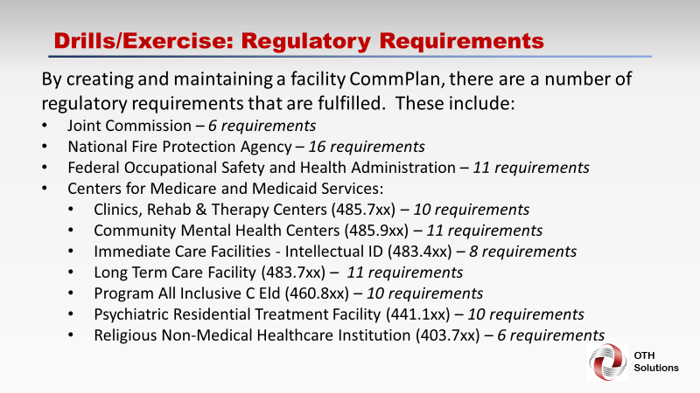 | Regulatory Requirements for Drills and Exercises  By creating and maintaining a facility CommPlan, there are a number of regulatory requirements that are fulfilled. These include:  - Joint Commission – 6 requirements  - National Fire Protection Agency – 16 requirements  - Federal Occupational Safety and Health Administration – 11 requirements  - Centers for Medicare and Medicaid Services:  - Clinics, Rehab & Therapy Centers (485.7xx) – 10 requirements  - Community Mental Health Centers (485.9xx) – 11 requirements  - Immediate Care Facilities - Intellectual ID (483.4xx) – 8 requirements  - Long Term Care Facility (483.7xx) – 11 requirements  - Program All Inclusive C Eld (460.8xx) – 10 requirements  - Psychiatric Residential Treatment Facility (441.1xx) – 10 requirements  - Religious Non-Medical Healthcare Institution (403.7xx) – 6 requirements
Slide 47  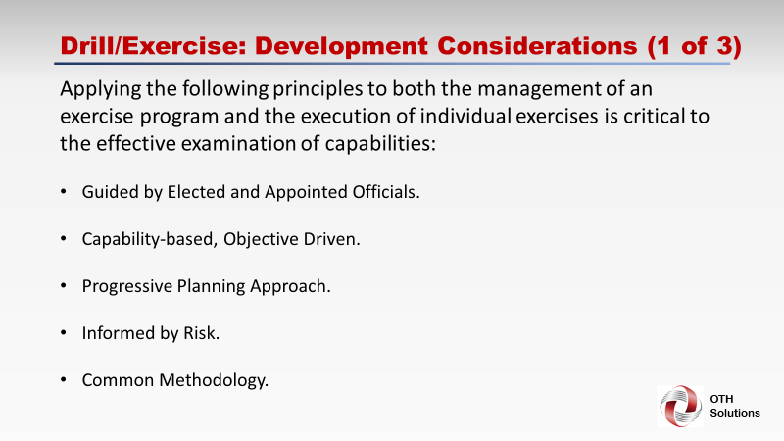 | Development Considerations for Drills and Exercises  Applying the following principles to both the management of an exercise program and the execution of individual exercises is critical to the effective examination of capabilities:  - Guided by Elected and Appointed Officials.  - Capability-based, Objective Driven.  - Progressive Planning Approach.  - Informed by Risk.  - Common Methodology.
Slide 48  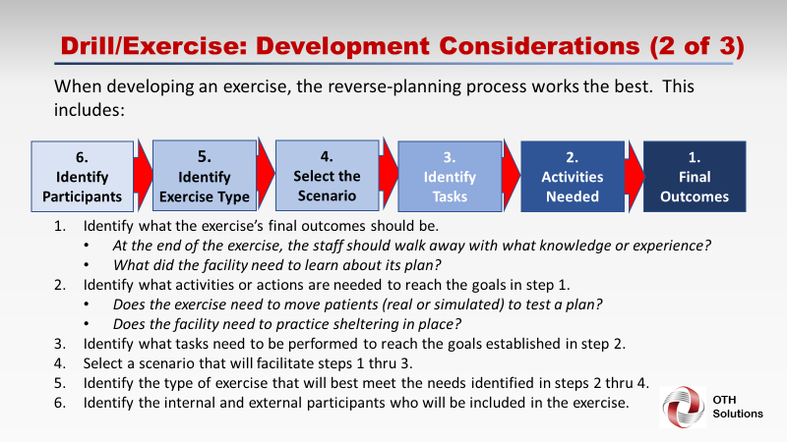 | 4.  Select the Scenario  5.  Identify Exercise Type  6.  Identify Participants  1.  Final Outcomes  2.  Activities Needed  3.  Identify Tasks  When developing an exercise, the reverse-planning process works the best. This includes:  - Identify what the exercise’s final outcomes should be.  - At the end of the exercise, the staff should walk away with what knowledge or experience?  - What did the facility need to learn about its plan?  - Identify what activities or actions are needed to reach the goals in step 1.  - Does the exercise need to move patients (real or simulated) to test a plan?  - Does the facility need to practice sheltering in place?  - Identify what tasks need to be performed to reach the goals established in step 2.  - Select a scenario that will facilitate steps 1 thru 3.  - Identify the type of exercise that will best meet the needs identified in steps 2 thru 4.  - Identify the internal and external participants who will be included in the exercise

Slide 49  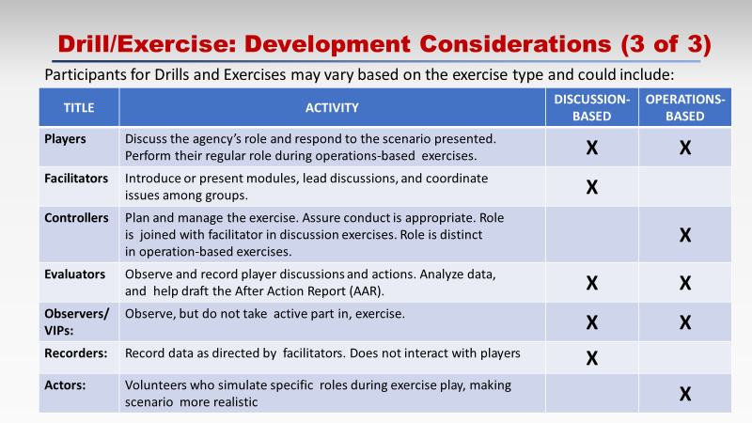 | Development Considerations for Drills and Exercises continued…  Participants for Drills and Exercises may vary based on the exercise type and could include:  TITLE ACTIVITY DISCUSSION-BASED OPERATIONS-BASED  Players Discuss the agency’s role and respond to the scenario presented. Perform their regular role during operations-based exercises. X X  Facilitators Introduce or present modules, lead discussions, and coordinate issues among groups. X  Controllers Plan and manage the exercise. Assure conduct is appropriate. Role is joined with facilitator in discussion exercises. Role is distinct in operation-based exercises. X  Evaluators Observe and record player discussions and actions. Analyze data, and help draft the After- Action Report (AAR). X X  Observers/ VIPs: Observe, but do not take active part in, exercise. X X  Recorders: Record data as directed by facilitators. Does not interact with players X  Actors: Volunteers who simulate specific roles during exercise play, making scenario more realistic X

Slide 50 | Facilitation Considerations for Drills and Exercises  When conducting a drill or exercise, consider the following:  - Safety First.  - Monitor for problems that may result in the need to stop or suspend the exercise or drill.  - Ensure the safety and mission of the facility. Real emergencies and patient care come before the drill or exercise.  - Monitor weather if the exercise is conducted outside or if participants have long distances to travel.  - If conditions change, consider moving the drill or exercise to another location or different date to ensure safety is maintained.  - Keep to the planned scenario, injects, and activities.  - Maintain a positive, encouraging, educational, and participant-friendly environment throughout the process.  - Consider beverages and snacks for drills and exercises lasting less than 2-3 hours. Events lasting greater than 4 hours, consider including a light lunch that is available throughout the event.
Slide 51 | Evaluation Considerations  The evaluation phase of a drill or exercise should include:  - Pre-planning and organizing the evaluation before the exercise takes place.  - Observe the exercise and collect data as soon as possible after the exercise.  - Analyze data and prepare preliminary After-Action Report (AAR) and Lessons Learned documents.  - Conduct an After-Action Conference to fill in gaps and get feedback.  - Identify improvements for implementation.  - Finalize the AAR/IP (Improvement Plan).  - Track implementation of the IP through completion.
Slide 52 | Documenting Your Efforts – EEGs  Exercise Evaluation Guides (EEGs) are pre-exercise documents used to identify important steps in the tasks and goals established during planning. They also guide evaluators to document exercise activities based upon capabilities.

Slide 52 continued… |  | EEGs should include:  - Capability Description: Overview description of capability to be evaluated.  - Capability Outcome: Description of the desired outcome of the capability, if it is performed correctly.  - Activity Description: Description of the activity to be evaluated. The activity is subordinate to and an element of the capability described.  - Tasks Observed: Detailed listing of tasks that must be completed to demonstrate the activity and capability. This includes an area to record the observed performance v. the target performance.  Example of a Healthcare EEG:  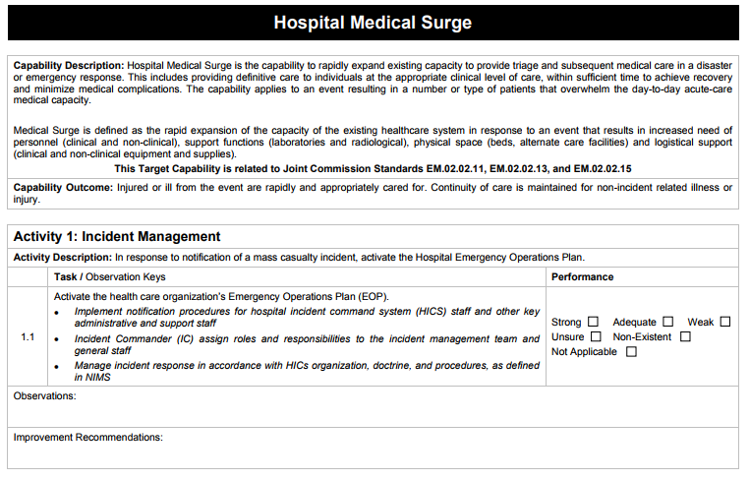  SOURCE: Exercise Evaluation Guides available at: https://hseep.dhs.gov/pages/1002_EEGLi.aspx
Slide 53 |  | Documenting Your Efforts-AAR/LL  After Action Report/Improvement Plan (AAR/IP):  - An After-Action Report is a record of exercise actions, used to implement changes and improve capabilities.  - AAR minimally includes:  - Executive Summary  - Exercise Overview  - Exercise Design Summary  - Analysis of Capabilities  - Conclusion  - Appendix A - Improvement Plan  - Appendix B to Z – References, tables, diagrams, pictures of the exercise, and other items necessary to fully document the drill or exercise.
 | Slide 53 |  | Documenting Your Efforts-AAR/LL continued…  Lessons Learned:  Brief summary of the individual outcomes as they related to the goals and additional important facts taken from the drill or exercise.  Improvement Plan:  Details corrective actions and the agency(s) responsible for the correction. Include who is responsible for the implementation, changes, and when they should be completed by.
 | Slide 54 |  | Drills and Exercises Section Review  In this section, we have:  - Definitions and examples of Drills and Exercises  - Regulatory requirements for Drills and Exercises in Healthcare Facilities.  - Exercise Developing, Facilitating, and Evaluating Considerations  - Documenting Your Efforts: After-Action/Lessons Learned

SECTION NOTES

SECTION 6: Wrap-Up and Departure

Slide 55 | Course Review  This course has reviewed:  - Hazard Vulnerability Assessment needs and resources.  - Emergency Operations Plan and Annex development considerations.  - Communications Plan Annex development considerations.  - Drill and Exercise development, facilitation, and recording considerations.
Slide 56 | Comments, Questions, & Concerns  How can we further assist you to complete your plans and assessments?
Slide 57 | Documents Deadline Reminder  The association would like to remind all facilities that the deadline to meet CMS requirements for submitting the HVA, EOP and CommPlan documents is by close of business on  NOVEMBER 17th 2017
Slide 58 | Additional Assistance from OTH Solutions  OTH Solutions is here to assist you should you require additional guidance in the following areas:  - HVA support and direction  - EOP and Communications Planning assistance  - Exercise development, facilitation and evaluation.  - Writing and developing Mutual Aid Agreements and Memorandums of Understandings for healthcare facilities.  - Other healthcare emergency management activities.

Slide 59 | On behalf of the:  DC Health Care Association  and  OTH Solutions:  THANK YOU  for your time and participation.

APPENDIX A – Acronyms and Abbreviations

AAR - After-Action Report
AAR/IP - After-Action Report/Improvement Plan

CDC - Centers for Disease Control
CMS - Centers for Medicare and Medicaid Services
CommPlan - Communications Plan
CPG - Comprehensive Planning Guide
CRiSTAL - Community-based Risk Screening=Adaption and Livelihoods Tool

DC - District of Columbia
DCHCA - District of Columbia Healthcare Association
DHHS - (U.S.) Department of Health and Human Services
DHS - (U.S.) Department of Homeland Security

ELO - Enabling Learning Objective
EOP - Emergency Operations Plan

FE - Functional Exercises
FEMA - Federal Emergency Management Agency
FSE - Full-Scale Exercise

HCO - Healthcare Organization
HSEEP - Homeland Security Exercise and Evaluation Program
HVA - Hazard Vulnerability Assessment

ICP - Incident Command Post
ICS - Incident Command System
IPAWS - Information and Public Awareness Warning Systems

KP - Kaiser Permanente

LL - Lessons Learned

MSCC - Medical Surge Capacity and Capabilities

NFPA - National Fire Protection Association
NIMS - National Incident Management System

Ops - Operations
OrgChart - Organizational Chart
OSHA - Occupational Safety and Health Administration

SOG - Standard Operating Guidelines
SOP - Standard Operating Procedure
Appendix A continued…

TJC - The Joint Commission
TTX - Tabletop Exercise

APPENDIX B – Emergency Operations Plan Overview
Emergency Operations Plan
Recommended Content Listing
No. | Section Title
i. | Promulgation Statement
The Promulgation Statement is used to show that the document is current, how it works in conjunction with other documents (supersedes, supports, etc.) and provides formal adoption of the EOP as the facility's All-Hazards EOP. The promulgation should be formally signed by the facility’s Chief Executive Officer or Delegated Officer. The facility may also elect to have all of the chief officers and division heads sign off on the document.
DEVELOPER'S NOTE: Refer to the TABLES tab to see an example of a Promulgation Statement. This example may also be cut and pasted into the final print document in the word document generated by this tool.
ii. | Record of Change
The Record of Changes provides readers a historical overview of the various additions, deletions and modifications to the plan. Each change recorded should including: change numbers, dates of changes, person who made change, and a summary of changes made.
DEVELOPER'S NOTE: Refer to the TABLES tab to see an example of a Record of Change table. This example may also be cut and pasted into the final print document in the word document generated by this tool.
iii. | Record of Distribution
The Record of Distribution provides a table with names, titles, agencies, facility's, and dates of delivery.
DEVELOPER'S NOTE: Refer to the TABLES tab to see an example of a Record of Distribution. This example may also be cut and pasted into the final print document in the word document generated by this tool.
SECTION I | Purpose, Situation Overview, and Assumptions
1.1 | Purpose
 | This explains the plan’s intent, who it involves, and why it was developed. Provide a paragraph to describe what the purpose for developing and maintaining the EOP.
1.2 | Scope
 | The scope provides a description of what types of incidents and under what conditions the plan will be activated.
1.3 | Situational Overview
The Situation Overview provides the reader with the general steps taken by the facility to prepare for disasters.
DEVELOPER'S NOTE: Most of the date in the following subsections can be obtained from the facility's local emergency management agency and customized to the facility's plan.
1.3.1 | Situational Overview: Location
 | Enter the location of the facility, including geographic location, county, and other geospatial facts.
1.3.2 | Situational Overview: Geographic
 | Provide general information about the location or community the facility serves.
1.3.3 | Situational Overview: Demographic
Demographic - This includes the general population information and specific populations of interest served by the facility. This may include: special needs population, business/industrial/agricultural patient groups, and other specialized community groups that may have an influence on the services and care provided.
DEVELOPER'S NOTE: Be sure to include any data relating to traveling or transient populations to the area. This may include: Season/Migrant farm workers, tourists and visitors, commuting workers, and others who may visit your area but do not reside there year-round. These populations may also have a bearing on your facility's continuity of care.
1.3.4 | Situational Overview: Areas of Interest
 | Enter any areas of interest that may draw non-residential populations to the area, which may also require additional or specialized healthcare planning.
1.3.5 | Situational Overview: Special Events
 | Enter any special activities within the community, or local to the facility, that may occur during the year that would require the facility to support. This may include: Fairs, concerts, festivals, parades, sporting or entertainment events, or other events resulting in a mass gathering of non-residential individuals.
1.3.6 | Situational Overview: Economic Base and Infrastructure
 | Identify the economic factors of the community that may have an effect on the facility's ability to provide healthcare to the community it services.
1.4 | Summary of the Hazard Analysis
 | Although the facility's complete Hazard Vulnerability Analysis (HVA) is provided in APPENDIX A of this plan, the summary is provided to describe the major findings of the facility's HVA in a brief form. The listing can be very brief and provide a list of the hazards in the order of severity. They may also be just the top five, ten, or twenty hazards.
1.5 | Planning Assumptions
 | In this portion of the plan, the Planning Assumptions list the various facts used by the planning team to prepare the EOP. These facts are assumptions or statements that are understood to be true in order for the elements in the EOP to be valid. These items may also identify function-based planning assumptions in specific annexes.
SECTION II: | Concept of Operations
2.1 | Introduction
 | Section II explains the decision maker’s or facility leadership’s intent with regard to how the facility's response to an incident will occur. It also provides an overview of how the facility will accomplish the goals, objectives, tasks, and/or missions to achieve the desired end-state. Provide a basic overview of the plan's operational concept.
2.2 | Plan Authorities
 | Describe who has the authority to activate the plan and how the plan is activated. Include the delegation of authority process should the primary authorized official is unavailable to activate the plan.
2.3 | Declaration of Emergencies
 | This section should provide the overall process that a declaration of emergency is enacted. This should include the forms, individuals, departments, and general actions expected to participate in the emergency declaration process.
2.4 | Legal Issues
 | Provide any brief descriptions of how legal questions/issues regarding emergency preparedness, response and or recovery actions, including liability protection that is available to responders may affect the facility.
2.5 | Event Identification, Assessment, and Initial Response
 | This section should describe, in general, the capabilities and processes the facility has in place to identify, analyze, and initially notify facility response staff of any event or activity that would require non-routine emergency response intervention.
2.5.1 | Threat Identification and Assessment Activities
Provide the general response steps or actions that are to be taken by staff when they witness or are informed of a threat. This should include some form of threat/hazard identification process (completed in 60 seconds or less) and general, appropriate reporting measures such as calling security or 911, reporting the incident to a supervisor, or other alerting measures by staff.
DEVELOPER'S NOTE: It may be helpful to adopt an incident reporting tool for staff to memorize or have printed on lanyards for reporting an incident. This may include a short (no more then 5-7 items) bulleted list of things to observe that will be helpful when reporting an incident.
2.5.2 | Protective Actions Overview
This section should describe, in general, the capabilities and processes the facility has in place to select and implement the appropriate protective action strategies and actions.
Information obtained from staff reporting the incident (Section 2.5a) may assist in the selection process. Below is a simple format to follow for determining an initial protective action:
- Analyze the hazard
- Determine protective action
- Determine public warning
- Determine protective action implementation plan
2.5.3 | Alerts and Notification
This section should describe, in general, the capabilities and processes the facility has in place to disseminate public warning messages to the occupants, including action steps by staff, visitors, patients, and others in the facility.
This section should also include the alert processes made to general staff, leadership, and non-routine emergency response staff regarding the incident.
2.5.4 | Overview of an Initial Non-Routine Emergency Response
This section identifies the Initial general activities associated with any non-routine emergency response. This may include the response of any special teams, resources, or other groups established and trained to support an incident.
DEVELOPER'S NOTE: This section is an introductory overview. Details about any special response groups or individuals should be presented in Section 4: Roles and Responsibilities Section of the plan.
2.5.5 | Overview of an Ongoing, Non-Routine Emergency Response
 | This section describes the general, overarching activities that may be implemented when an incident extends beyond a few hours or a defined period of time such as an operational shift (i.e. 8a-4p, 4p-12a, 12a-8a). Details about extended response activities should be noted in the Annexes of those events addressed.
2.5.6 | Summary of Special Needs Populations at Risk
 | In this portion of the plan, the Planning Assumptions list the various facts used by the planning team to prepare the EOP. These facts are assumptions or statements that are understood to be true in order for the elements in the EOP to be valid. These items may also identify function-based planning assumptions in specific annexes.
2.5.7 | Emergency Operations Center (EOC)
 | Although the details of the EOC are provided in Annex Q, this section should introduce the activation, location, secondary location, and short list of resources for the EOC. Also include an overview of the staff assigned to the EOC
2.5.8 | Continuity of Operations Overview
 | Because healthcare operations do not stop when a disaster happens, this section should identify how the facility will support daily, routine services and what services may be altered because of the disaster response.
2.5.9 | Demobilization of Response Efforts
 | Provide a brief overview of the process to demobilize the incident response process and return to normal operations.
2.5.10 | Recovery Operations Overview
 | Identify the various, overarching steps to begin and complete recovery for most emergency responses. Referring to the various Annexes for details on specific event recovery is acceptable practice.
2.5.11 | After-Action Activities Overview
Identify the general steps in documenting the incident response and recovery using HSEEP guidelines for after action reporting.

After-Action Report (AAR) - actions the facility takes to review and discuss their response to identify strengths and weaknesses in the emergency management and response program.
- Identify and describe the agencies and the actions they will take to organize and conduct AARs, how recommendations will be documented and how they will be used to improve local readiness (reviewing actions that were taken, identifying equipment shortcomings, improving operational readiness, highlighting strengths/ initiatives, changing plans/procedures, acquiring new or replacing outdated resources, training).
- - Identify the agencies that will be responsible and the actions they will take to ensure that deficiencies and recommended changes that are discovered through exercises are implemented/accomplished, including ensuring that changes are made to the plan. After-Action Reporting and Corrective Action Plan/Improvement Plan guidelines and templates are contained in HSEEP Volume III
2.6 | Emergency Management Partners
2.6.1 | Healthcare Partners
 | Identify what healthcare partners within the local community may be able to assist the facility should an emergency occur.
2.6.2 | Community Support Partners
 | Identify what community support partners may be able to assist the facility. This may include local law enforcement, fire and EMS, local emergency management, public works, and others.
2.6.3 | State and Federal Support Partners
 | List the state and/or Federal support partners that may be able to assist the facility should local resources not be available. Include a brief description of what services those partners could provide.
2.6.4 | Other Support Partners
 | List and describe any other support partners that could provide assistance during an emergency.
2.7 | Overview of Staffing for Disasters
 | Describe in general terms how plans address the physical, programmatic, and communications needs of children, individuals with disabilities and others with access and functional needs, and household pets and service animals.
2.8 | Annex Overview
 | Provide a brief overview of the various annexes located at the end of the plan and list the hazard situations they address or response actions they support.
SECTION III | Organization of Assignment and Responsibilities
3.1 | Introduction
 | This section provides an overview of the individuals and their key rolls during an emergency.
3.2 | Hospital Incident Command System
 | Introduce the Incident Command System for your facility. This may include the alignment of hospital staff titles with ICS positions, a description of each position, and the general duties.
3.2.1 | Incident Command and Emergency Support Functions
If your facility recognizes the Emergency Support Function structure within its ICS structure, be sure to identify the various ESF identifiers with each position in the organizational chart. These may include:
- Leadership
- Patient Care
- Facility Security
- Physical Facility Support (Maintenance and Utilities)
- Facility Infrastructure (Food, resources, or other logistical items) Support Activities
- Staff Management
- Administrative and Finance Management of the Incident
3.2.2 | HICS Command Chart
 | Provide a brief overview of the command chart as it interacts with external agencies.
3.2.3 | HICS Command Staff
This section identifies the primary and supporting activities of the individuals assigned to the staff assigned to the incident command staff of the facility. A listing of the individuals assigned to the staff positions. The roles and responsibilities of these positions should be clearly defined. These positions should include:
- Incident Commander
- Public Information Officer
- Safety Officer
- Other Officers within the facilities command structure.
3.2.4 | HICS General Staff
This section identifies the roles and responsibilities of the HICS general staff identified in the facility command's organization chart. These positions include:
- Section Chiefs
- Branch Directors
- Division/Group Supervisors
- Unit Leader/Manager
- Strike Team/Task Force Leader
- Activity Coordinators (rarely used and not NIMS supported)
3.2.5 | Disaster Staff Management
 | Provide an overview of the general staff management activities during a non-routine emergency. Refer details to Annex U.
3.3 | Critical Infrastructure and Key Resources Support
 | Describe how roles and responsibilities for CIKR protection and restoration are managed within the facility.
3.4 | External Agency Members of the ICS Organization
Outline the responsibilities assigned to each organization that has an emergency response and/or recovery assignment of responsibility in the plan. Include elected officials, local departments and agencies, state agencies, federal agencies, regional organizations, volunteer resources, VOADs, and private sector businesses and groups.
DEVELOPER'S NOTE: Identify and describe how EOP-tasked agencies maintain current notification rosters, standard operating procedures, and checklists for all assignments of responsibility in the plan.
3.5 | Mutual Aid and Memorandum of Understanding Listings
 | Provide a brief listing and description of the Mutual Aid Agreements/ Memorandum of Understandings (MAA/MOUs) that are in place with your facility. Full copies of the MAA/MOUs should be provided in ANNEX B of the facility's EOP.
3.6 | Volunteer Management Overview
Provide a brief overview of how the facility will manage clinical and non-clinical volunteers during an emergency response. Also provide a very brief overview of the following:
- Roles and responsibilities of the managers of these volunteers.
- Roles and Responsibilities of the volunteers.
- Identify, briefly, the vetting process of the volunteers.
Be sure to Reference Annex V: Volunteers and Donations Management
4 | Direction, Control, and Coordination
4.1 | Introduction
 | Optional section to introduce the various topics that will be discussed in this section.
4.2 | Authority to Initiate Actions
This section provides two (2) important references.
- Describe who is responsible for activating the EOP. The decision will be made by the responsible leadership within the facility, and
- Describe how is the responsibility for implementation of the EOP assigned.
4.3 | Command Responsibility for Specific Actions
Describe the general guidance for non-routine emergency operations from that of the facility's normal operational activities.
DEVELOPER'S NOTE: This section identifies how both normal/routine facility operations work with the non-routine emergency response activities. A compare and contrast or other description separating the activities and responsibilities should be provided.
4.3.1 | HICS Span of Control
Identify the abilities, and limitations, that the HICS organization has over the facility during a non-routine emergency or disaster. Identify any areas where the Incident Commander must engage with leadership before acting on tasks identified during the response. These topics may include:
- Limited control over human resource management of specific staff during an event (physicians, union employees, etc.)
- Ability to change or modify corporate/facility policy in support of the event
- Other items that may require leadership oversight.
4.3.2 | External Response Interaction
This section identifies those agencies that may have control or operational oversight to the facility during an incident. Included in this section should:
- Identify the agencies/positions/titles that will command incidents and have overall responsibility to coordinate response operations (Fire Service for chemical, Law Enforcement for riot, Mayor/Manager for natural hazard, etc.).
- Identify agencies that have tactical and operational control of response assets.
4.3.3 | Regional Control and Coordination
 | This section should discuss the facility and multi-facility coordination systems and processes used during an emergency. This may include regional protocols and procedures for healthcare facilities during specific emergency conditions or regional disaster coordination efforts through the local Health and Medical Coalition support services during a disaster.
4.4 | Unified Command Operations for Separate Healthcare Facilties
 | This section is for those facilities who are part of a larger healthcare system and that system elects to use a unified command and control program to manage emergency preparedness and response activities. Include any details that may support how the operation may function.
5 | Information Collection, Analysis, and Dissemination
5.1 | Introduction
 | This section describes the required critical or essential information common to all operation identified during the planning process.
5.2 | Information Needs during an Event
Describe critical short- and long-term information collection, dissemination, analysis needs, priorities and operations.
Include general procedures that identify the type of information needed, where it is expected to come from, who uses the information, how the information is shared, the format for providing the information, and specific times the information is needed are maintained at the facility's Emergency Operations Center.

For a detailed listing of these activities, refer the reader to ANNEX C: Crisis Communications and Public Information Plan
5.3 | State, Regional, and/or Agency Information Collaboration
Identify intelligence position (e.g., fusion center liaisons) requirements for the facility's emergency operations center’s (EOC). Be sure to identify any plans for coordination between the facility's EOC and the Federal/State/Regional fusion center.
DEVELOPER'S NOTE: This information can be organized in various ways. Using tables, matrixes, and charts to demonstrate to the reader how to identify the source of data based on the topic and content will be helpful during the response phase of an incident.
6 | Communications
6.1 | Introduction
 | This section provides an overview of the systems for providing reliable and effective communications among facility staff, external agencies, and the patients and families in the facility.
6.2 | General Communications Activities
 | This section should include the general communications protocols for disaster operations. It could also include a listing of communications resources available for disaster response with a description of each. Additional details would be found in ANNEX C: Crisis Communications and Public Information Plan
6.3 | Public Warning and Alert Systems
 | Enter a summary of the public warning and alert systems available to the facility.
6.4 | Communications Integration Overview
 | Describe the framework for providing communications support and how the facility’s communications network integrates with the regional or national disaster communications network. Additional details would be found in ANNEX C: Crisis Communications and Public Information Plan
6.5 | Patient Records Management during Disasters
Describe the framework for providing maintaining and sharing patient records and patient care information documentation during a disaster. This may include:
- Downtime record management.
- Record management during surge.
- Record management during the execution of protective actions (evacuate, relocate, shelter-in-place).
Additional details would be found in ANNEX C: Crisis Communications and Public Information Plan
6.6 | Overview of Interoperable Communications
Identify and summarize interoperable communications plans, Including:
- Describe how 24-hour emergency communications are provided and maintained both within and external to the facility.
- Identify additional internal and external communications resources available in the event of a failure of any other communications system.
Additional details would be found in ANNEX C: Crisis Communications and Public Information Plan

DEVELOPER'S NOTE: Also consider providing a brief description of the facility's resource listing, Communications SOPs, available compatible frequencies/trunking systems used by the facility and/or other support agencies during a response (including contiguous local, state, and private agencies).
6.7 | Public Information Staff
 | Provide a review of the activities and staff who provide public information to both internal and external partners. For detailed activities, referee to ANNEX C: Crisis Communications and Public Information Plan
6.8 | Public Information Dissemination Activities
Briefly review the operations that facilitate collaboration with the general public, including sector-specific watch programs.

For detailed activities, referee to ANNEX C: Crisis Communications and Public Information Plan
7 | Administration, Finance, and Logistical Support
7.1 | Introduction
 | This section provides an overview of the administrative, finance, and logistical support activities to the EOC's activities during a non-routine emergency situation.
7.2 | Logistical Support Considerations
- This section identifies the various "All-Hazards" response plans established to support non-routine emergency response and the EOC during an incident. These plans vary for each facility but may include the following:
  - Central Supply Support Activities
  - Bed Management/Case Management for Medical Surge Support
  - Medical Services Support (Dialysis, Respiratory Therapy, etc.)
  - Staff Support (Food, accommodations, and personal support)
  - Advanced Deployment of Units (i.e. Pharmacy tech to ED, Resp.Tech to ED, disaster cache supply placement, etc.)
  - Human Resources Support (in EOC for call backs, altered scheduling, and other HR support activities)
  - Other specialty resource deployment for specialized situations.
- Identify and describe the steps that will be taken to overcome identified resource gaps including identifying resources that are only available from outside the facility's immediate location (Hazmat support, Potable Water, Special response teams, Respiratory Ventilator augmentation, etc.).
7.2.1 | Inter-Facility Logistical Resource Management
 | Describe the logistics and resource management mechanism used to list, identify, locate its storage location, identify other pertinent information regarding the resources tracked.
7.2.2 | External Logistical Resource Management
 | Describe and identify the actions and agencies that will be involved in resource identification, procurement, facility activation, tracking, mobilization, delivery, staging, warehousing, distribution, maintenance, demobilization and recovery.
7.2.3 | Logistical Resources for Supporting Special Needs Populations
 | Provide information about specialized equipment, facilities, personnel, and emergency response organizations currently available to respond to emergency operations, including response to support children, individuals with disabilities, and others with access and functional needs.
7.2.4 | Disaster Cache Resource Listing and Management
 | Specialized, disaster cache inventory should be maintained to list the types of resources available, amounts on-hand, locations maintained, and any restrictions on their use. Whenever possible, these resources should be typed based on FEMA resource-typing standards.
7.1.5 | Resource Allocation Considerations
 | Describe the process used to identify private agencies/contractors that will support resource management issues (waste haulers, snow removal firms, spill contractors, landfill operators, potable water, etc.).
7.2 | Administrative Support Considerations
 | This section provides the administrative actions used by the facility to support non-routine emergency operations.
7.2.1 | Administrative Support: Documentation Services
Identify what administrative resources the facility can provide to support the documentation activities of the response and recovery actions from a disaster.
DEVEOPER'S NOTE: This information can also be discussed for each emergency response function or for specific hazards.
7.2.2 | Administrative Support: After-Action Support
 | Describe the resources the facility can provide to assist in the After-Action reporting of the incident, especially in the areas of: actions taken, resources expended, economic and human impacts, and lessons learned.
7.2.3 | Administrative Support: Damages and Claims Compensation
 | Identify the various manuals, reports, forms and reimbursement documents required for the purpose of cost recovery, damage assessment, incident critique, historical record, etc.).
7.3 | Financial Support Considerations
 | This section provides an overview of the financial activities required to support a non-routine emergency for the facility.
7.3.1 | Financial Documentation Activities
 | Describe the actions that will be taken to document costs incurred during response and recovery operations (personnel overtime, equipment used/expended, contracts initiated).
7.3.2 | Financial Recovery Activities
 | Provide an overview of the financial recovery activities as an introduction to this section in this area.
7.3.2a | Financial Recovery: Insurance
 | Describe the impact and role that the facility's insurance coverage has in recovering costs (self-insured, participation in the National Flood Insurance Program (NFIP), homeowner policies, etc.).
7.3.2b | Financial Recovery: Federal/State Assistance
This section discusses the Federal and state support after an incident occurs. The section should include:
- Describe/identify the various programs that allow the facility's and the response/support agencies to recover costs (Small Business Administration, FEMA Public Assistance Program)
- Describe the methods of pre- and post-state or federal declaration funding for the facility’s household pets and service animal’s preparedness and emergency response program, including how to capture eligible costs for reimbursement by the Public Assistance Program, eligible donations for volunteer labor and resources, and eligible donations for mutual aid resources.
8 | Plan Development and Maintenance
8.1 | Introduction
"The EOP is a living document. Problems emerge; situations change; gaps become apparent; Federal, state, regional, and/or regulatory requirements are altered; yet the EOP must be adapted to remain useful and up-to-date. This section identifies the requirements and the individuals responsible for maintaining, reviewing, and updating the Basic Plan, annexes, appendices, and supplementary documents, such as checklists, SOPs, etc. Once planning documents are developed, a system of maintenance must be established to ensure they are current. The following sub-sections provide an example of types of information that should be addressed in this section of the EOP, and is provided as a starting point for developing language for this section."
SOURCE: EOP Basic Planning Template FY10 CPD 101, FEMA, 2010
8.2 | Plan Development
 | Provide the history of the facility's EOP, how it was created, when it was originally developed, and describe any of the major or historical changes it has gone through over the years.
8.3 | Plan Revision Process
 | Describe the process the revised EOP will go through before it is presented for review and authorization.
8.4 | Review Requirements
- Describe the process used to have the EOP reviewed and approved. If the process for annexes differs then that of the EOP, include the annex review process as well.
- Describe the actions the facility takes to annually review, change and revise the plan, including the role of support agencies in an integrated planning process
9 | Authorities and References
9.1 | Introduction
 | This section provides the legal basis for emergency operations and activities
9.2 | Plan Authorization and Supporting Legislation
 | Identify local ordinances/statues; state laws, revised codes, administrative codes, Attorney General opinions; and federal laws, regulations, and standards that specifically apply to the development and implementation of the plan, emergency management, and homeland security.
9.3 | References Section
 | Identify reference materials used to develop the plan, prepare for, or respond to disasters/ emergencies (general planning tools, technical references, computer software).
9.4 | Federal, State, Regional, and Local Authorities
 | List the government authorities related to this plan.
9.5 | Regulatory Authorities
 | List the non-government and regulatory authorities associated with this plan.
10 | Education and Training
10.1 | Introduction
 | This Section provides an orientation to the process used by the facility to provide or develop training programs and other types of educational programs for staff. Enter an optional introduction to this section here.
10.2 | General Training Activities
 | This section provides an overview of the general training requirements for staff, including training for general staff and those with disaster response assignments.
10.2.1 | NIMS Compliance
 | Identify and describe the actions that will be taken to ensure that the facility meets National Incident Management System (NIMS) training requirements.
10.2.2 | Specialized Staff Training Activities
 | Describe the process for identifying training requirements of facility staff to prepare for and respond to disasters (i.e. – training “needs assessment").
10.3 | Drills and Exercises
Enter the various drills and exercises used by the facility in this section. The listing may also include annual drills and exercises conducted internally or with local partners on an annual, semi-annual, or other basis.

Describe the methods and agencies used to conduct an exercise and evaluation of the plan.
10.3.1 | Drills and Exercises: Needs Assessment
Based on previous exercise results, annual HVA findings, and other evaluation tools; describe how the facility will:
- Identify the various types of drills and exercises required.
- Identify the actions and methods the facility will use to evaluate preparedness for identified hazards, including recommendations made to improve (training, resources, procedures, exercise design).
10.3.2 | Drills and Exercises: Development and Facilitation Requirements
    - Identify and describe the actions the facility will take and identify the agencies and tools that will be used to develop and conduct the exercise(s).
DEVELOPER'S NOTE: Guidance in exercise design and conduct can be accessed by consulting Homeland Security Exercise and Evaluation Program (HSEEP) Volume II.

    - Describe how the facility will incorporate exercise requirements of other laws/committees into the exercise program. (ARC, Local fire/EMS/PD, LEPC, State, Terrorism, etc.).
10.3.3 | Drills and Exercises: Plan Testing
 | Identify and describe the types of activities that will be employed by the facility to annually exercise and test the Plan (Seminars, Workshops, Tabletop Exercises, Drills, Functional Exercises, Full-Scale Exercises), including how actual events may be used in lieu of exercises. Refer to HSEEP Volume I for exercise definitions.
10.3.4 | Drill and Exercise Delivery and Tracking
 | Once the education component has been identified for need and content, and the preparation of the document has been made; delivery and tracking of the success of that effort is needed. Identify the methods for delivering and tracking of the educational products that the facility has recruited to use in this section.
10.4 | Public Education Program
 | Provide a brief introduction to the public education component of the EOP in this section.
10.4.1 | Public Education Topic Identification and Preparation
 | Identify and describe what topics need to be presented to the patients, families, visitors, and general community regarding emergency management response and recovery for the facility. Be sure to include those staff members who would be tasked with developing and presenting these educational programs.
10.4.2 | Public Education Delivery and Tracking
11 | Acronyms, Abbreviations, and Glossary (OPTIONAL)
 | This section includes the acronyms, abbreviations and glossary sections for the facility's EOP. This can be provided in Section 11 OR as an Annex or Appendix to the EOP plan body.
11.1 | Acronyms and Abbreviations
Enter the acronyms and abbreviations listing here, OR use the table in the TABLES worksheet and enter that into the word processing formatted document created from this tool.

DEVELOPER'S NOTE: There is a Acronyms and Abbreviations table available in the TABLES tab of this tool.
11.2 | Glossary of Terms
 | Enter the Glossary of Terms listing. This is based on the terms utilized in your plan.

This page intentionally left blank.

APPENDIX C – Communications Plan Overview
Communications Plan
Recommended Content Listing
No. | Section Title
 | Table of Contents
 | Using your document software, create a table of contents for the EOP.
C.1 | Administration Section
 | This section provides general, overarching and supportive data to the plan.
C.1.1 | Purpose
 | Provide a purpose statement (introduction) to the annex.
C.1.2 | Situation Overview
 | Identify and describe any "global" assumptions made and the methods used when preparing the communications annex.
C.1.3 | Annex Assumptions
 | This section identifies those assumptions identified during the planning activities and lists those operational and conditional assumptions associated with any part of the communications process, systems, and/or staff.
C.2 | Concept of Operations
C.2.1 | General Communications Activities
 | This section provides the general overview of communications for the facility.
C.2.2 | Introduction of Crisis Communications
This section provides an overview of the systems for providing reliable and effective communications among facility staff, external agencies, and the patients and families in the facility. The section should also provide an overall picture of the various activities, units, and staff who provide public and media messages for a non-routine emergency. These sections may include a brief introduction to the following:
- Public Information Officer and Staff
- Forms of Public Messaging Used by the Facility
- Rumor Control and Media Monitoring Unit
- Disaster Communications Equipment and Usage
C.2.3 | General Emergency Communications Protocols
 | This section should include the general communications protocols for disaster operations. It could also include a listing of communications resources available for disaster response with a description of each.
C.2.3.1 | Internal Clearance & Approval
 | Provide the facility's protocol for the preparation, cleaning, and final approval of information that is released to external agencies and media. Be sure to include any special modifications in these protocols for non-routine emergency information release.
C.2.3.2 | Data Disclosure
 | Enter the facility's policy on disclosure of patient and operational data for external sources here. Ensure that any instruction includes provisions for emergency release. Also consider standardized message forms in the event that the authorities are unable to approve the information quickly.
C.2.3.3 | Interagency Communication Coordination
 | During a non-routine emergency, information may need to be shared with various groups, both internal and external to the incident command staff. This section defines that coordination of information.
C.2.3.4 | Activation of the Crisis Communications Team
 | The Crisis Communications team needs to be available for supporting incidents 24/7. This section identifies how the team is alerted to an incident and what they should do when they are alerted.
C.2.3.5 | Activation of JIC
 | In the event that a JIC is required, a process for activating the center is necessary. This section is provided to describe the process for activation and assembly of the JIC.
C.2.3.6 | News Dissemination Methods
 | This section identifies how general information is collected and sent to the general public. This should include the vetting process for any messages sent to the public.
C.2.3.7 | News Media Communications
 | This section identifies how general information is collected and sent to the media. This should include the vetting process for any messages sent to the media.
C.2.3.8 | Spokespersons
 | The facility may have a policy on who may be elected as a spokesperson for the facility, or one of its many departments/units. Provide the policy on selecting and preparing facility spokespersons here.
C.2.3.9 | Criteria for Authorizing Interviews
 | Like policies on spokespersons, facilities may also have policies on how and when interviews with the media are given. Enter that policy here.
C.2.3.10 | News Conference
 | In the event that a news conference is requested or necessary, the facility should have a policy on the request, establishment, content review, selection of conference pannel members, and other specifics related to the operation of a media conference. Enter that policy information here.
C.2.3 | Emergency Frequency Designations
 | This section provides a listing of the various activities conducted on the radio frequencies available to the facility. A table identifying the type of radio unit, channel identification, frequency for that channel, and the dedicated communications activities could be used.
C.3 | Public Warning and Alert Systems
C.3.1 | Introduction
 | This section provides an overview of the various public warning and emergency alert systems in place and available to the facility.
C.3.2 | Warning and Alert Systems
 | This section provides information on each warning and alert system available to the facility. This should include the details about each system, such as capabilities and limitations of the systems, areas they cover (and don't cover), and any information that may assist the facility in responding to a disaster.
C.3.3 | Conditions for Use
 | Provide the various usages of the public warning systems available to the facility. This may include both routine and emergency usages.
C.3.4 | Communications Integration Overview
 | Describe the framework for providing communications support and how the facility’s communications network integrates with the regional or national disaster communications network.
C.3.5 | Overview of Interoperable Communications
Identify and summarize interoperable communications plans, Including:
- Describe how 24-hour emergency communications are provided and maintained both within and external to the facility.
- Identify additional internal and external communications resources available in the event of a failure of any other communications system.

DEVELOPER'S NOTE: Also consider providing a brief description of the facility's resource listing, Communications SOPs, available compatible frequencies/trunking systems used by the facility and/or other support agencies during a response (including contiguous local, state, and private agencies).
C.3.6 | Pre-Scripted EAS Messages
 | It is often good practice to have pre-scripted messages for non-routine emergency alert and notification purposes on those incidents that occur frequently or require notification within minutes. Provide a listing of the messages, or provide each message here. If included here, it is suggested to make each message a sub-section to C.3.7.
C.3.7 | Local Media Support for Facility Warnings
 | Local media can sometimes assist in reaching out to off-duty staff, as well as the community the facility serves, by placing EAS messages on their station. List the media agencies that support this feature here and provide the details necessary to enlist these services.
C.4 | Public Information Staff
C.4.1 | Introduction
- Provide a review of the activities and staff who provide public information to both internal and external partners.
- Identify and summarize interoperable communications plans.
- Describe how 24-hour emergency communications are provided and maintained within the facility.
- In the facility’s Resource Manual and/or SOPs, identify the compatible frequencies/trunking systems used by agencies during a response (including contiguous local, state, and private agencies).
C.4.2 | Public Information Officer
C.4.2.1 | Selection of the Primary and Alternate PIO
 | Enter the facility's policy for selecting a primary and alternate PIO. This may include a job description, desired requirements and interim selection policies.
C.4.2.2 | Duties and Responsibilities of the PIO
Enter the job duties and responsibilities associated with the PIO during a non-routine emergency. This may include:
1. Even, daily, and/or hourly goals and expectations.
2. Special activities expected.
C.4.2.3 | PIO Support Team
 | If the PIO requires assistance, identify who would be available, qualifications of these team members, and the general operational activities of the team that supports the PIO>
C.4.3 | Rumor Control Team (RCT)
C.4.3.1 | Duties and Responsibilities of the RCT
 | Identify the personnel, activities, and specifics of the RCT members. Include any goals, initiatives, and other activities required in conducting rumor control and medical monitoring for the facility.
C.4.3.2 | RCT Staffing
 | Enter the general job description and qualifications of those individuals who would be assigned to media monitoring and RC activities.
C.4.4 | Joint Information Center (JIC)
C.4.4.1 | General Activities
 | Define and describe the general activities that are to occur within the JIC.
C.4.4.2 | Triggers for Activating a JIC
 | Enter the triggers or reasons during an event that would cause the facility to determine that a JIC was necessary. These can be any reason the facility identifies as a reason that media control, message coordination, and other JIC services would be necessary.
C.4.4.3 | JIC Alert and Notification Protocols.
 | Enter the process for alerting and notifying facility personnel that a JIC is needed, needs to be established, and needs to report to the JIC for job assignment.
C.4.4.4 | Supporting External JIC
 | Enter the protocols for the facility JIC when operating with and coordinating messages and community information activities with JICs external to the facility. These external JICS may be district or regional healthcare or emergency management JICS.
C.4.4.5 | Internal JIC Location and Set Up
Enter the details related to opening a JIC for the facility. This may include:
1) Pre-identified areas for staff to work from.
2) Media conference areas.
3) Resource needs for media management.
C.4.4.6 | JIC Operations
Provide an overview of JIC operations. This may include:
1) Initial Operations subsection
2) Ongoing operations (daily or operational period) activities.
3) Deactivation and Demobilization activities for the JIC.
C.5 | Patient Records Management
C.5.1 | Introduction
 | Introduce this section. This is optional.
C.5.2 | Alternate Records Management
 | Enter the specifics about using alternate patient records management systems during non-routine emergencies.
C.5.2.1 | Alternate Record Management Triggers
 | Enter what events or activities would cause the need for utilizing alternate record management systems, policies, and/or procedures.
C.5.2.2 | Alternate Records Management Operations
 | Provide any operational guidance for the alternate records management to be used during non-routine emergencies for the facility. This may include the change from electronic to paper forms through advanced forwarding of records between patient care systems, both internal or external to the facility.
C.5.3 | Downtime Procedures
 | Each facility has a means of continuity of care where patient records are concerned. Provide a description of how the facility manages computer downtimes and the recording of patient information in this section.
C.5.4 | Medical Surge Records Management
Describe the framework for providing maintaining and sharing patient records and patient care information documentation during a disaster. This may include:
- Downtime record management.
- Record management during surge.
- Record management during the execution of protective actions (evacuate, relocate, shelter-in-place)
C.5.5 | Patient Privacy Measures
 | Describe the measure involved to protect patient data access.
C.6 | At-Risk Populations Planning
C.6.1 | Introduction
 | Provide an introduction to this section. This is optional.
C.6.2 | Introduction
 | Identify and describe the resources and activities the facility will take to inform special/functional populations within the community. Include those communications activities both internal and external of the facility.
C.7 | Communications Resources
C.7.1 | Introduction
 | Provide an introduction to the communications resources (logistics) of the facility.
C.7.1 | Introduction
 | Provide an introduction to the communications resources (logistics) of the facility.
C.7.1 | Introduction
 | Provide an introduction to the communications resources (logistics) of the facility.
C.8 | Plan Development and Maintenance
C.8.1 | Introduction
 | Provide an introduction to the plan development and maintenance section of the this annex.
C.8.2 | Plan Development
 | Provide the history of the facility's Communication Annex, how it was created, when it was originally developed, and describe any of the major or historical changes it has gone through over the years.
C.8.3 | Plan Revision Process
 | Describe the process the revised facility's communications annex will go through before it is presented for review and authorization.
C.8.4 | Review Requirements
 | Describe the process used to have the annex reviewed and approved.
C.9 | Education and Training
C.9.1 | Introduction
 | This Section provides an orientation to the process used by the facility to provide or develop training programs and other types of educational programs for staff. Enter an optional introduction to this section here.
C.9.2 | General Training Activities
 | This section provides an overview of the general training requirements for staff, including training for general staff and those with disaster response assignments.
C.9.2.1 | NIMS Compliance
 | Identify and describe the actions that will be taken to ensure that the facility meets National Incident Management System (NIMS) training requirements.
C.9.2.2 | Specialized Staff Training Activities
 | Describe the process for identifying training requirements of facility staff to prepare for and respond to disasters (i.e. – training “needs assessment").
C.9.3 | Drills and Exercises
 | Enter the various drills and exercises used by the facility in this section. The listing may also include annual drills and exercises conducted internally or with local partners on an annual, semi-annual, or other basis.
C.9.3.1 | Drills and Exercises: Needs Assessment
Based on previous exercise results, annual HVA findings, and other evaluation tools; describe how the facility will:
- Identify the various types of drills and exercises required.
- Identify the actions and methods the facility will use to evaluate preparedness for identified hazards, including recommendations made to improve (training, resources, procedures, exercise design).
C.9.3.2 | Drills and Exercises: Development and Facilitation Requirements
A) Identify and describe the actions the facility will take and identify the agencies and tools that will be used to develop and conduct the exercise(s).
DEVELOPER'S NOTE: Guidance in exercise design and conduct can be accessed by consulting Homeland Security Exercise and Evaluation Program (HSEEP) Volume II.
C.9.3.3 | Drills and Exercises: Plan Testing
 | Identify and describe the types of activities that will be employed by the facility to annually exercise and test the annex (Seminars, Workshops, Tabletop Exercises, Drills, Functional Exercises, Full-Scale Exercises), including how actual events may be used in lieu of exercises. Refer to HSEEP Volume I for exercise definitions.
C.10 | Authorities Section
C.10.1 | Introduction
 | This section provides the legal basis for emergency operations and activities
C.10.2 | Plan Authorization and Supporting Legislation
 | Identify local ordinances/statues; state laws, revised codes, administrative codes, Attorney General opinions; and federal laws, regulations, and standards that specifically apply to the development and implementation of the plan, emergency management, and homeland security as they relate to the communications annex.
C.10.3 | References Section
 | Identify reference materials used to develop the plan, prepare for, or respond to disasters/ emergencies (general planning tools, technical references, computer software).
C.10.4 | Federal, State, Regional, and Local Authorities
 | Enter the listing of the Federal, state, regional and local authorities who support or interact with this annex. Describe their interaction briefly.
C.10.5 | Regulatory Authorities
 | Enter a list of the regulatory authorities having bearing on this annex here.
C.11 | References Section
C.11.1 | Acronyms and Abbreviations
This section includes the acronyms, abbreviations and glossary sections for this annex.

DEVELOPER'S NOTE: There is a Acronyms and Abbreviations table available in the TABLES tab of this tool
C.11.2 | Glossary of Terms
 | This is based on the terms utilized in your plan.

